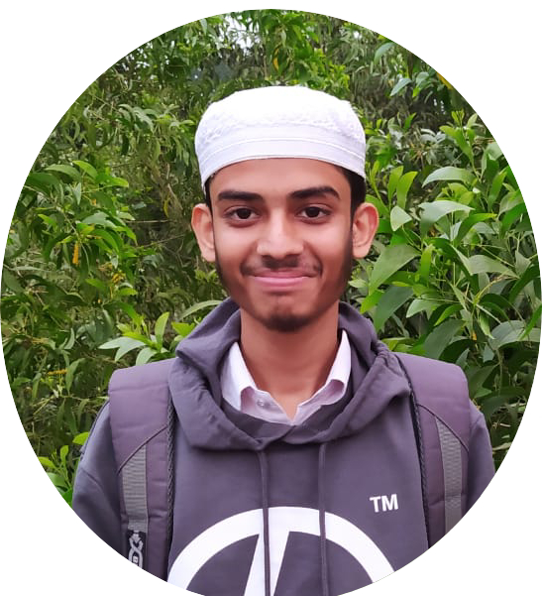

CONTACT
📧 syednazmusshakib94@gmail.com
📞 +8801401997130
Sex: Male
Date of Birth: 12/09/2004
Bangladesh,Sylhet,Habiganj.

SKILL
- HTML,CSS,BOOTSTRP,JAVASCRIPT,C,C++,DATASTRUCTURE,GITHUB,ALGORITHM,PYTHON,TAILWIND,REACT.JS

LANGUAGE
- English
- Bangla

Shakib

Programmer & SoftWere Developer.

I started my programming journey with C and solved some problems, then learned C++ and solved some problems and did some projects with HTML, CSS, Bootstrap and JavaScript. Also I learned Python Java, PHP. Learned Data Structure Algorithms and solved these related problems.

WORK EXPERIENCE
- Html Css Bootstrap Frontend Project
- Django,JavaScript Backend Project
- Problem Solving DataStructure & Algorithm C++ Language

EDUCATION

Habiganj Polytechnic Institute:-
2022-2025
In this college I am
studying Diploma in Engineering, CST.
- 1st Semister CGPA->3.25 Out Of 4
- 2st Semister CGPA->2.65 Out Of 4
- 3st Semister CGPA->2.94 Out Of 4

Habiganj Technical School & College:-
2019-2021
I attended this ‍School in class nine and class ten, welding and fabrication trade.
CGPA->4.25 Out Of 5

Habiganj High Schoo:-l
2018
In this college I studied class eight in C branch.
CGPA-> 3.00 Out Of 5

